US Fashion Retail Industry Report 2025

Overview

The US fashion retail sector in 2025 faces a mix of slow growth and rapid change. Industry analysts expect low single-digit revenue growth, persistent inflation, supply chain uncertainty, and intense price competition. Online shopping now accounts for roughly half of fashion purchases, pushing brands to invest in digital channels.

Sales Trends

US fashion sales have stabilized after the post-COVID bounce. The US apparel market is projected at about $365–370 billion in 2025. E-commerce continues to gain share, while physical stores still maintain a significant portion of sales.
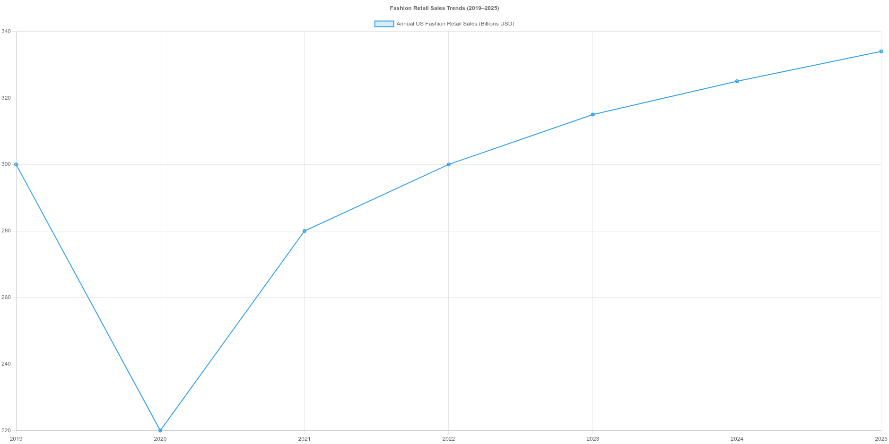

Labor and Workforce Challenges

Rising wages and high turnover are major challenges. Retailers are investing in employee retention, training, and flexible scheduling to reduce costs and improve productivity.
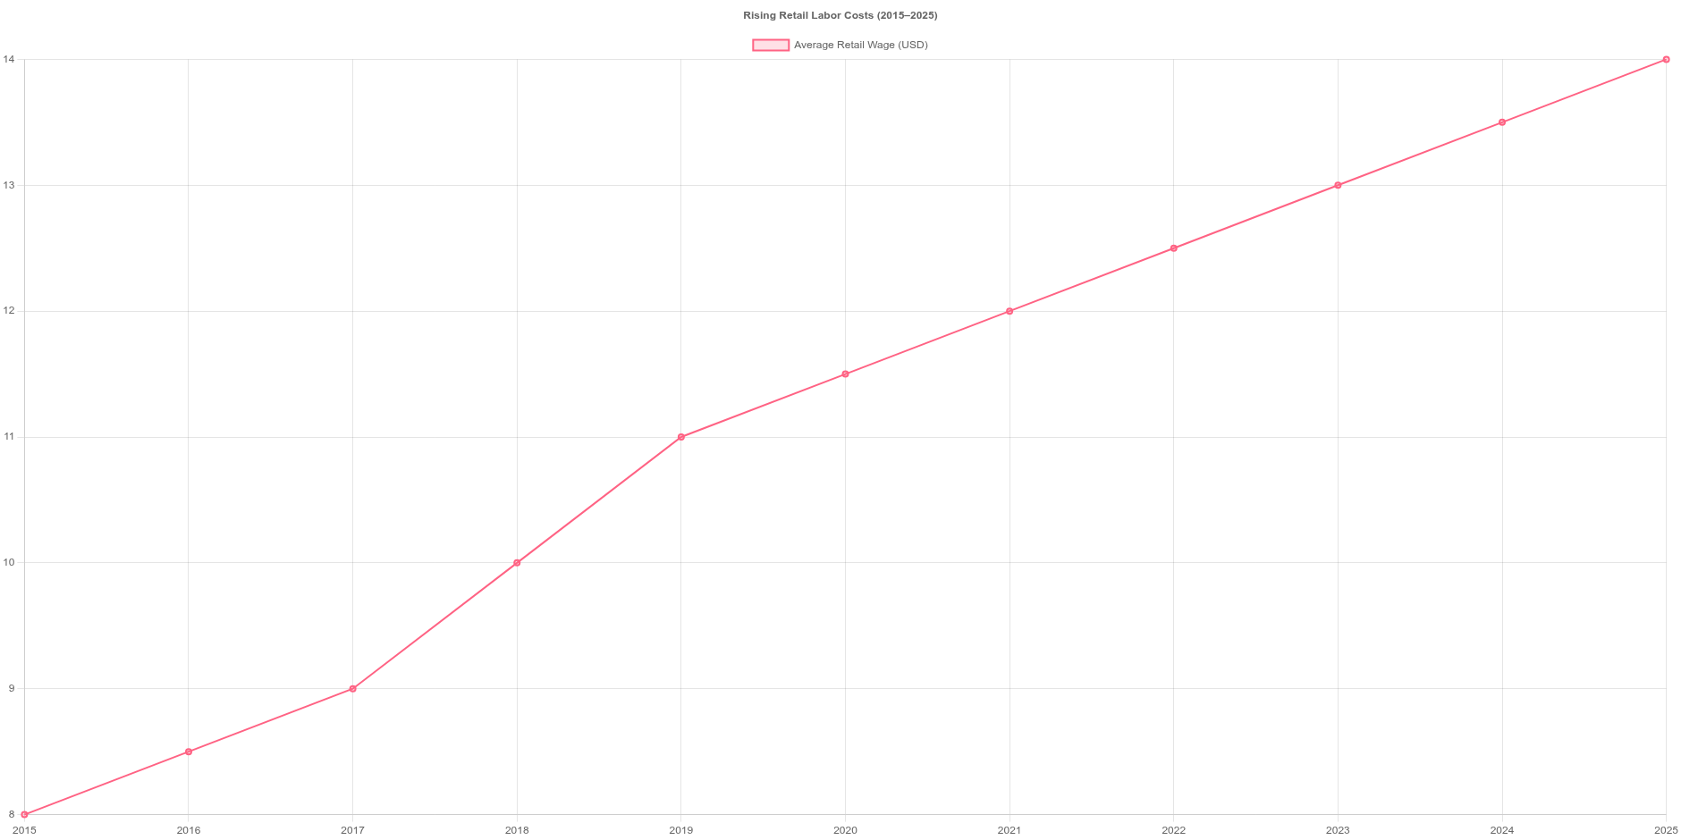

Digital Adoption and Innovation

Retailers are integrating AI, AR/VR, and mobile apps to improve efficiency and customer experience. Omnichannel strategies and personalized digital marketing are becoming standard practice.
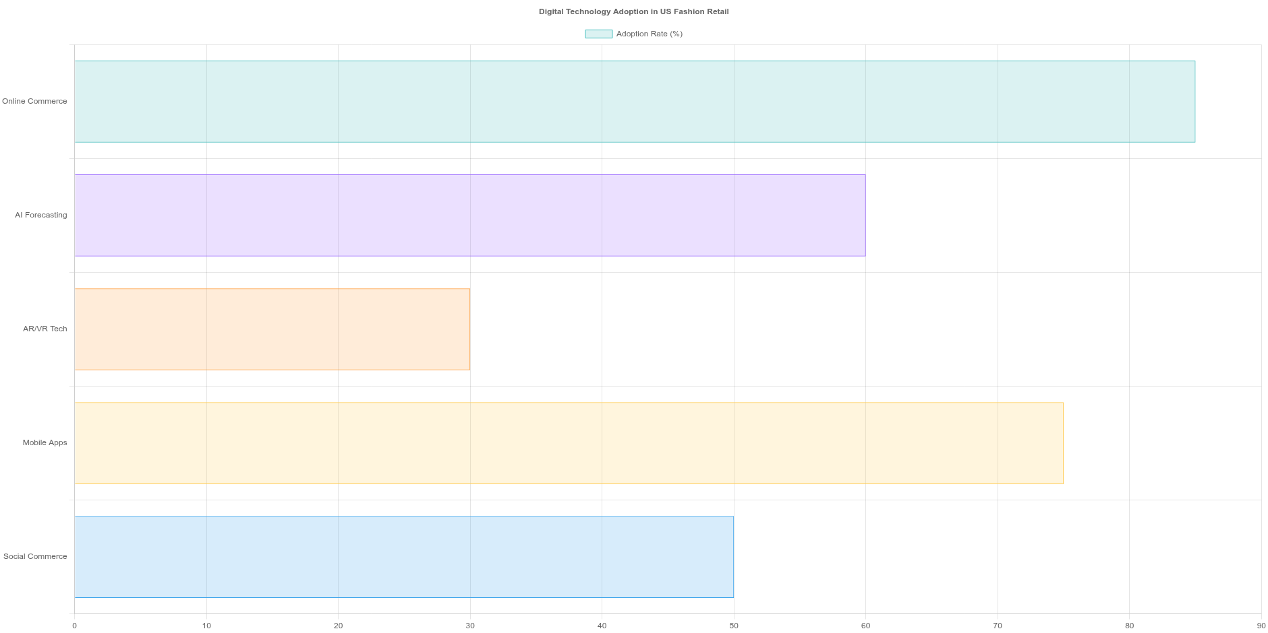

Customer Foot Traffic Trends

Physical-store visits have not fully recovered across fashion retail. Luxury brands see declines, while off-price/value retailers experience growth. Retailers are enhancing in-store experiences and linking online and offline channels.
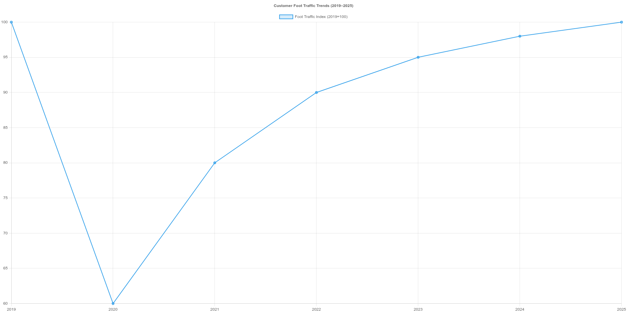

Proposed Solutions

Omnichannel Integration: Unified inventory and seamless BOPIS.
AI and Automation: Demand forecasting, pricing optimization, warehouse robotics. Enhanced In-Store Experiences: AR/VR fitting rooms, interactive displays.
Workforce Improvements: Flexible schedules, training, career paths.
Value and Loyalty Focus: Expand off-price segments and loyalty programs. New Revenue Streams: Retail media networks, subscriptions, resale platforms.

Investor-Relevant Insights

Off-price and discount retailers outperform.
Digital leaders gain efficiency and higher conversion. Customer experience investments drive retention and sales. Cost control and labor management are critical.
Macro factors like inflation and price wars remain risks. Innovation and M&A provide growth and tech capabilities.

